Flood Action Plan
Guidance Notes
Remember
Do not undertake any activity that may put yourself or others at risk.
If there is a risk to life, call 999
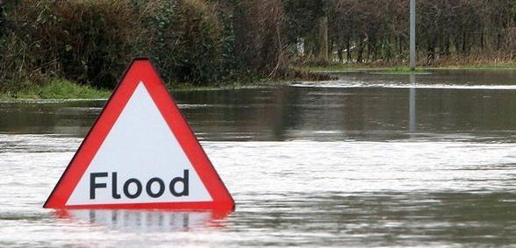

District / Borough: Council:

Community / Group:

Parish Council:
Upper Tier Authority:

Document Control
Version / Date | Amendments | Review Date | Author
1.3 / Aug 2018 | Full review | Aug 2019 | CSW Resilience Team
1.4 / Jan 2020 | Review | Aug 2020 | CSW Resilience Team
1.5 / Nov 2021 | Review | Aug 2022 | CSW Resilience Team

Important

Response to emergencies at a local level is supported by the Parish/Town Council though their Emergency Plan. The Parish/Town Council Emergency Plan outlines generic arrangements for responding to any emergency and describes the appropriate links to the Local Authority.

This template should be completed in consultation with or by a Parish Council representative familiar with that plan in order to effectively coordinate available resources and prevent duplication or conflict in arrangements.

Contents
 |  | Page
1. | Introduction……………………………………………... | 2
 | 1.1 Flood Action Plan Overview……………………….. | 2
 | 1.2 Flood Response Structure…………………………. | 2
2. | Completing the template……………………………… | 3
 | 2.1 Contacts & Volunteers……………………………... | 3
 | 2.2 Useful Resources…………………………………… | 3
 | 2.3 Local Actions………………………………………… | 3
 | 2.4 Action Map…………………………………………… | 5
 | 2.5 Key Risk Areas……………………………………… | 5
 | 2.6 Resources Inventory……………………………….. | 5
 | 2.7 Telephone Cascade……………………………….. | 6
3. | What Next?…………………………………………….. | 6

- Introduction

  - Flood Action Plan Overview
When completed, the Flood Action Plan is a tool to help Flood Groups and communities better protect themselves from the effects of flooding. This can be achieved by:
- Co-ordinating an agreed level of preparedness, response and recovery activity that will increase the resilience of the community and reduce the impacts of flooding;
- Specifying actions to be taken when heavy rainfall is forecast/occurring or severe weather and flood alerts/warnings are issued;
- Providing appropriate contact details and useful information to those able to support the delivery of actions outlined in the plan; and
- Documenting known mechanisms of flooding, areas at risk and any potential impacts on the community.

  - Flood Response Structure

In response to any emergency the following co-ordination structures are established as required between responding agencies. As illustrated, the Flood Action Group should link into these structures via the Parish/Town Council to ensure all actions taken are appropriate, coordinated and supported by the wider response.

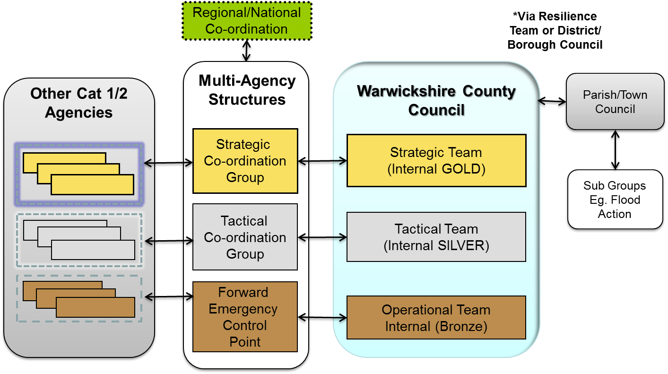

- Completing the Template

2.1 Contacts & Volunteers
Before including contact details in the plan ensure you have permission and are clear under which circumstances they wish to be contacted. You may wish to consider:
- How and where the plan will be stored and distributed;
- Who will have access to the plan; and
- How any personal details will be used.
Consider seeking permission from the following to include daytime and evening contact details:
- The Parish/Town Council;
- Volunteers who would co-ordinate and complete activity outlined in the plan; and
- Agencies able to respond to developing issues such as blocked drains & gullies.
2.2 Useful Resources
Here you may wish to include details of any sources of information that would be helpful prior to and during a flood event, these may include:
- Local radio/news stations;
- Agencies and individuals on social media such as Twitter and Facebook; and
- Forecasting and monitoring websites.
For more information on available resources, see www.cswprepared.org.uk
2.3 Local Actions
Any local arrangements agreed as part of this plan must consider the safety of volunteers in the first instance. In order to do this, the following considerations should be made:
- Does the activity put the volunteer/s safety at risk? For example is it near to a road, river or floodwater?
- Is any specialist or protective equipment required to complete the activity and is training required to use it?
- Does the activity involve any lifting or strenuous activity? Is training required to complete it safely without injury?
- Are volunteers covered by liability insurance when completing tasks should they have an accident? It may be possible to make arrangements to provide this through the Parish/Town Council.
The response role of the flood action group will vary between communities depending on available resources and local arrangements.
Whatever level of activity is agreed, it should be closely co-ordinated with the Parish Council to ensure it is complimentary to processes already in place under its Emergency Plan.
Activities likely to be completed include:
- Monitoring alerts/warnings/forecasts alongside local conditions and communicating the risk within the community; and
- Monitoring locally agreed triggers such as river or well levels.
When triggers are met:
- Moving vehicles out of flood risk areas;
- Deploying available community flood defences such as sandbags and pumps;
- Assisting community members to deploy their property level protection; and
- Securing street/garden furniture liable to be washed away.
For Example:
Local Actions
Trigger |  | Action | Responsible Roles
BEFORE | Flood Alert Issued | Monitor local conditions and forecasts | Flood Warden
BEFORE | Flood Warning Issued | Assist deployment of property level protection on Watery Lane | Flood Warden, Volunteers
DURING | Access to village affected by flood water | Publicise alternate routes | Parish Council
DURING | Properties likely to be affected by flood water | Deploy available resources to protect properties | Volunteers
AFTER | Floodwater receding | Monitor local forecasts to establish likelihood of further flooding | Flood Warden
AFTER | Flood alert no longer in force | Clear debris left by floodwater | Volunteers

2.4 Action Map
This section can be used to support the activities described in the previous part of the plan. Using a map of the area, illustrate where the described actions will take place. Some of the following tips may help you:
- Keep your map simple and easy to use, highlight key landmarks that are easily identifiable;
- If there is a large area at risk, consider separating it into ‘zones’ of responsibility – you could colour code these and assign volunteers to each one; and
- Highlight places of safety, meeting areas and stores for equipment – this will also highlight if your resources are kept in the best place.
2.5 Key Risk Areas
Here you can describe the types of flood risk affecting the area and what the potential impacts are on the community. This overview can be weighed against the actions you have previously described allowing you to highlight any gaps in your response or areas for improvement.
For Example:

Key Risk Areas
Source | Area | At Risk | Potential Impact
River Avon & Surface Water from adjacent fields | Binton Road | - Access road to village (1 of 2)  - 1 Primary School  - 5 residential properties,  - 2 local services – shop & pub | - Limited access to village  - No local amenities

2.6 Resources Inventory
Here you can document the deployable resources available to you as a group, where they are stored and how you can arrange access to them. Consider what resources may be available within your community as well as those owned by the flood group.
Examples of resources include:
- Protective / Hi Visibility Clothing;
- Tools & Equipment;
- Deployable flood protection products such as sandbags and pumps; and
- Vehicles / Transport

  - Telephone Cascade
The purpose of a telephone cascade is to alert members of the community/flood group of relevant issues during an incident. It can assist in quickly activating members before, during and after an incident. A telephone cascade should identify the path in which people within the community can be contacted during activation.
For Example:

The nominated person does not have to be a single person; it can be anyone who activates the cascade. Each person can be responsible for ringing someone else, so that the emphasis is not on one person to call all people listed in the plan.
You could also consider using messaging based Apps instead such as WhatsApp to help alert and communicate with members of the community.
- What Next?
Whilst primarily this plan is for you and your community, the information within it is extremely valuable for the Parish/Town, District/Borough & County Councils to consider in their planning and response arrangements.
Now it is complete:
- Provide your Parish/Town Council with a copy directly and us, the Resilience Team at cswrt@warwickshire.gov.uk;
- Set a schedule by which your plan will be reviewed; and
- If you use the plan, afterwards consider what worked well and what didn’t - use this to improve your arrangements.

For tips and advice on personal & community resilience, visit cswprepared.org.uk
Alternatively if you have any questions please contact the CSW Resilience Team at: cswrt@warwickshire.gov.uk



